TUARP “Times”
  - Volume 39 April 2021
Trent University Association of Retired Persons
  - https://mycommunity.trentu.ca/tuarp
  - tuarp@trentu.ca
  - Editor: Tony Storey tonystorey71@gmail.com
  - Mailing address:
TUARP, Trent University, 1600 West Bank Drive, Peterborough, ON, CANADA K9L 0G2
Faculty Co-Chair: To be named; Staff Co-Chair: Gina Collins 2020 - 2022

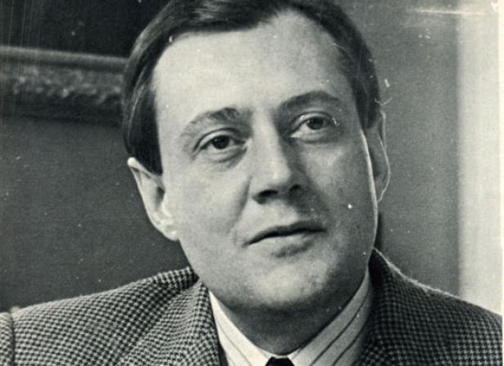

(Photo courtesy of Trent University Library and Archives, Parks’ Peterborough)

Editorial: The man with sunshine in his eyes
One of my favorite Van Morrison songs is And It Stoned Me. It describes a day excursion by two boys and includes this lyric:
On the way back home we sang a song
But our throats were getting dry
Then we saw the man from across the road
With the sunshine in his eyes.
To me, Tom Symons will always be the man with the sunshine in his eyes.
May 2011
361 Park Street North
One of my annual tasks as Alumni Director was to ensure the preparation and presentation of Honorary Alumni Association membership certificates to the new Honorary Degree recipients. The certificate had signature lines for the Alumni Association President and the Honorary Association President Tom Symons.
For a long time, the Honorary Degree recipient's name would be entered by the calligraphy of Louis Taylor.
I would bring the certificates to the Symons home for Tom to sign. He would comment on the recipients, "I know them all, Tony." As I prepared to take my leave in 2011, knowing my own retirement was imminent, I was aware that this would be the last occasion for this most pleasant task. As Tom escorted me to the door, he startled me by asking, "Would you like to see my electric chair?"
The electric chair was a stair lift chair. His legs were beginning to weaken and this allowed him to get up and down the stairs. I duly admired it and he invited me to sit in it and give it a test drive. When I returned from my free ride, there was laughter in his eyes. "I am very pleased with this. It means I can stay here and continue my work until I kick off."
April 29, 1994
Champlain College Great Hall, Nassau Campus
The occasion was the retirement of Founding President and Vanier Professor Symons. The previous year I had been asked by Vice President Susan Mackle to chair the Symons: A Celebration committee to honor Tom as he retired from his active teaching role. I was magnificently assisted by a who's who of colleagues including the late Michael Treadwell, Pauline Mills and Nancy Sherouse.
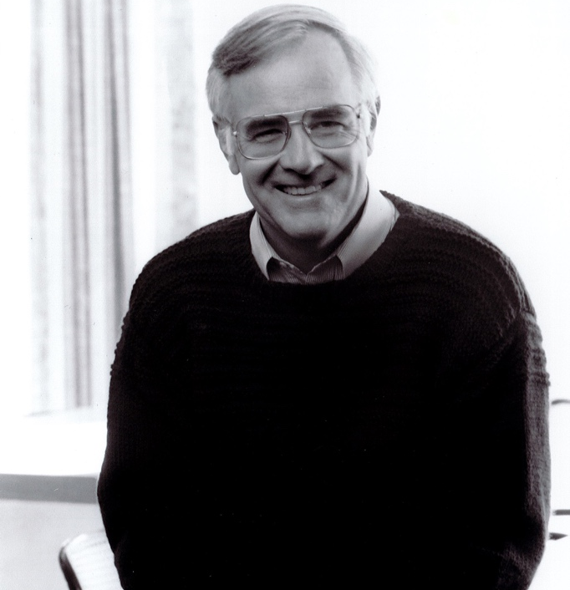
Michael Treadwell (Photo courtesy of Trent University Library and Archives.)
In true Trent style, there was a robust speakers list including student, staff, faculty, alumni, faculty, Board and community. The Great Hall was packed and overflow seating was arranged for the Private Dining Room and the Junior Common Room. Through their close relationship with Nancy Sherouse, Tom and Christine had been carefully informed about the planning and intentions for the Celebration. But one item was withheld: the Senate and Board approval of renaming Nassau Campus as Symons Campus.
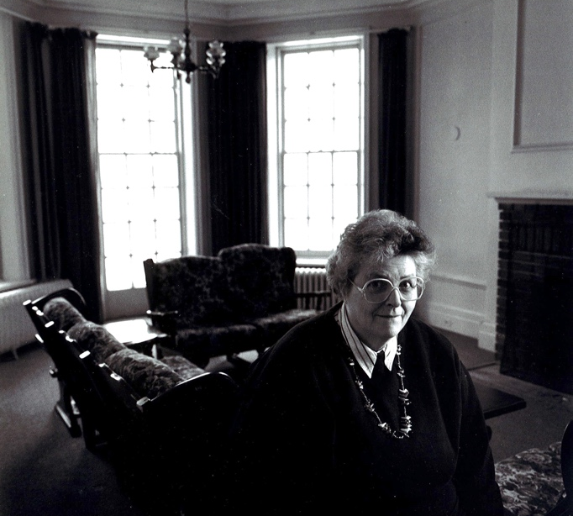
Nancy Sherouse (Photo courtesy of Trent University Library and Archives.)
A new sign had been made and it was hidden behind a curtain that could be lowered by our confederates in the Private Dining Room. At the agreed moment, the announcement was made and the sign revealed.
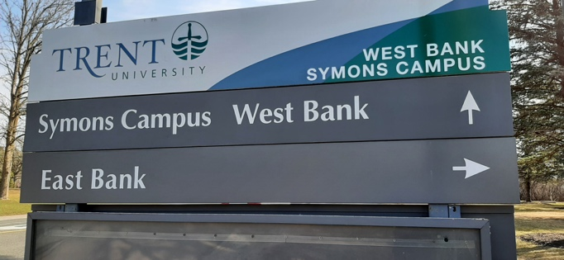
A sign identifying the Symons Campus.
It is hard to do justice to the sound the audience released at that moment. Applause, cheering, wonder, joy, affection and respect, excitement. Later as the evening adjourned and I made plans for the next day delivery of a beautiful table handcrafted by the Carpenter's Shop for the Symons home (the original brass door handles of Rubidge Hall were embedded in the table top), Tom leaned over and said, "This has been awfully nice Tony, but it is very important that the university not lose sight of the Nassau name. It is part of the history of this site".
September 1971
Champlain College Senior Common Room
I arrived at Trent for my first year after graduating from an independent high school called the University of Toronto Schools (UTS).
I knew that Trent's president Professor Tom Symons was also a UTS graduate. The beginning of term activities included a college dinner presided over by the new-to-Trent College Master Brian Heeney. Through a UTS classmate (also in 1st year) and his family's links to Brian and Goodith Heeney, we found ourselves invited back to the Senior Common Room for sherry. It is where I first met President Symons. Our final assembly at UTS the previous June had marked the retirement of a teacher/librarian, Mr. L.H. Newell.
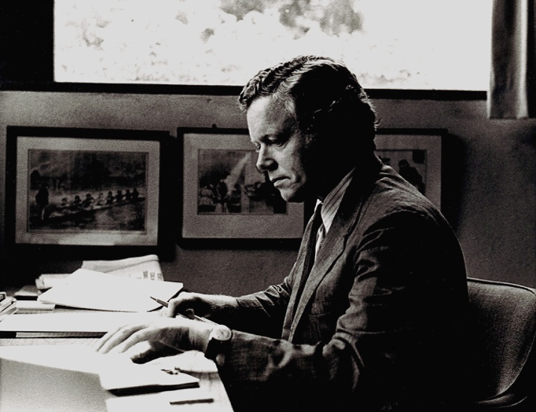
Brian Heeney. (Photo courtesy of Trent University Library and Archives.)
He had bottle-thick glasses, a very prominent hearing aid and was a tall man of some size. A schoolboy rumour had it that he was once the wrestling champion of Australia. His retirement speech left no doubt that he knew of all the mischief perpetrated under his watch in the library. As he spoke our wonder turned to respect and then laughter. He was afforded a tumultuous ovation in a Goodbye Mr. Chips crescendo.
As we sipped sherry in the Common Room, I spun this tale to the very generous listener that Tom Symons was. Many others have written about his open and welcoming interest in the person he was conversing with. I certainly felt it that night almost 50 years ago. As I made my way back to my residence room, my feet barely touched the path. I had been welcomed to my college and university in this highly personal and engaged manner. I was welcome at Trent, to participate, and perhaps, to contribute.
January 27, 2017
A Telephone Call
Earlier in January I received a distressing call from Original Class member Margie Lightbody. Her popular and respected husband Bob had suffered a serious stroke and would not survive. Margie and her family were planning the Celebration of Life for January 28. Would I please attend and speak about Bob Lightbody's relationship to Trent University?
When I retired as Alumni Director I had rather hoped that I might also be retiring from public speaking. But I wasn't about to say no to Margie Lightbody. I knew that Tom Symons might be unable to attend for health reasons but that it was essential to have a message from him at the Celebration. The relationship of the founding years alumni to Professor Symons is powerful and enduring.
I called Tom early in the week and indeed he was not having a good week. "Let me think about it Tony and let's speak later in the week."
I called him on the Friday. He was waiting for the ambulance to take him to the hospital. "But let's see what we can put together right now, Tony."
And here it is:
Tom asked me to express his profound sadness that could not attend today due to recent hospitalizations. He recalled that he had been good friends with Bob since Trent's beginning and how much that friendship meant to Tom and Christine. And how that friendship deepened when it included Margie. I will conclude with these words from our founding president, "Robert Lightbody has made an immense contribution to Trent as one of its founding students and in many other ways over the years. We were lucky to have him and we will never forget him."
July 2019
Home of President Leo Groarke, Lakefield
President Groarke had allowed TUARP to hold an afternoon tea as a belated celebration of Tom Symons's 90th birthday. The University had held a hugely attended event at the Athletics Centre in May. Our TUARP Tea was to be a mostly informal and much smaller opportunity to toast our wonderful colleague. When I approached Tom about the idea, he was much in favour and pleased that President Groarke would invite us. "But I don't think we need any more fuss about the founding president's birthday." I agreed and made arrangements that a current member of the university staff would pick Tom up and oversee the use of a wheelchair. Tom called me on the morning of the event to indicate his attendance was in doubt. We agreed to press on and if he didn't make it, I would phone him with a full report later. The Tea started at 3 pm and as 4 pm approached, I thought we would not get to enjoy his company. At that point, a car pulled into the driveway with Professor Symons in the front seat. We huddled briefly in the driveway as the wheelchair was retrieved. Tom's eyes were in full amusement mode as he explained that they were just about to set out when his nurse arrived. "She told me I was not to go, and she stomped her foot. I told her, My good woman, I have found that an hour in the company of friends is the best medicine. And she relented!"
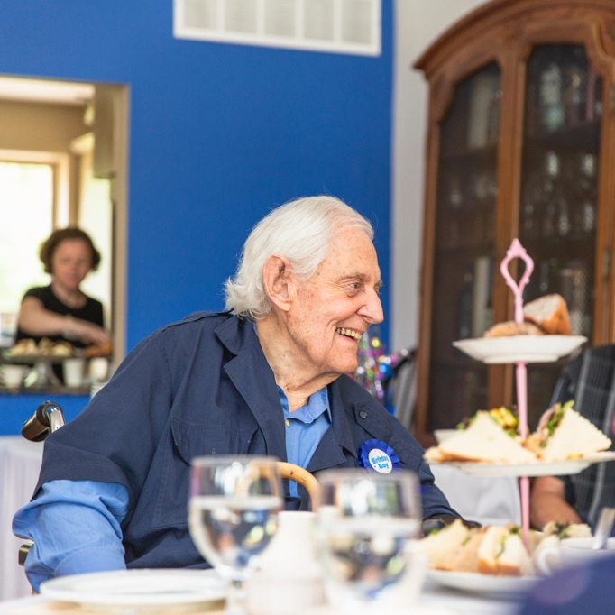
Tom Symons at the TUARP Tea in 2019 (Photo courtesy of Alumni Engagement and Services.)
As the proceedings unfolded I honoured my word not to make a fuss about the Founding President's benchmark birthday. However we were pleased to celebrate the 90th birthday of the Vanier Professor Emeritus. Our retired colleague Glen Easson (and Vanier Seminar alumnus) performed a Canadian song trilogy which had Tom smiling and singing the words. His plan to drop by the tea and slip away quietly after half an hour turned into a two and a half hour visit, sealed with a dram or two of President Groarke's fine single malt whiskey collection.
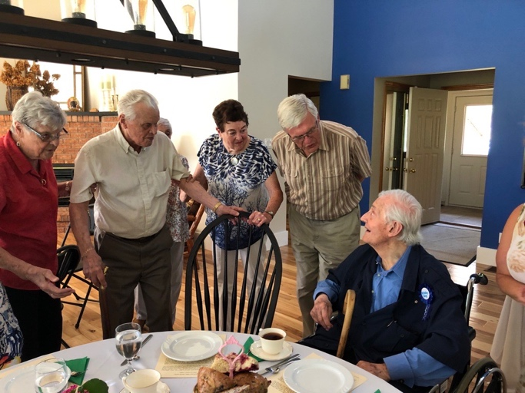
Tom Symons (right) at the TUARP Tea in 2019. (Photo courtesy of Alumni Engagement and Services.)
And as the car taking Professor Symons home departed from Lakefield, the car stereo was playing Stompin' Tom loudly.
"Don't turn it down" I heard him say. "I like Stompin’ Tom."
Tony Storey, TUARP Times Editor

“You made Trent what it is”
Tom Symons was a remarkable contributor to the university he founded and to Peterborough, Ontario, Canada and the Commonwealth. I joined Trent as a 25-year-old faculty member in 1967; like many in those years, I had yet to complete my doctoral thesis. I remember Tom telling me something like: “You had better get it done. Your generation does not have the luxury I had of not completing.”
I have many, many other fond memories - participating in the Symons seminar at Rubidge Hall with distinguished visitors Tom brought to Trent, observing somewhat sceptically with other lefties the student demonstration in 1968 that begged him not to leave us for a political career, enjoying many great parties and receptions that he and Christine hosted at Marchbanks, serving on the committees that approved his initiatives to establish Canadian Studies and what has evolved into Indigenous Studies (both firsts in Canada), sipping tea and gossiping in the Cottage at PR (when, as Vanier Professor, he somewhat incongruously reported to me as Dean and Provost), having him join the students, alumni and faculty in the struggle to save Peter Robinson College, and working with him on the committee that planned the splendid 50th Anniversary of Trent in 2015. I am so glad that he lived to experience the extraordinary tribute that was organized for him for his 90th birthday in 2018. There is so much more, but I will just say thank you, old friend. You made Trent what it is.
David Morrison

An august presence and genial manner
I first met Tom Symons in 1971 when applying for a job at Trent. In his fourth floor office in the Library, proudly overlooking the river and vistas of Ron Thom’s architecture, he was in the fullness of his powers. With his august presence and genial manner, it was a bit like meeting royalty. Only later did it become clear that he was entering his last year as President, with Trent already facing pressures to lower its sights and fit more modestly into the provincial system.
I came to know him better, to the point of a real friendship, when a few years later he renewed his physical link with Trent, and based himself at Peter Robinson College. After Paul Wilson moved out to the new Athletics complex Tom moved from Sadleir House into the small building between Reade House and the Townhouses then known as The Cottage. There, for two decades, amidst his legendary towers of papers and correspondence, he presided over the Vanier Seminar, worked tirelessly on a raft of high level public service assignments, and offered tea and conversation to anyone who sought his company and wisdom. I have particularly fond memories of Tom at the slightly tipsy conclusion of SCR dinners, joining normally buttoned down faculty and administrators round the piano to lead us in a spirited rendition of Bye Bye Blackbird. Under more somber circumstances, we became re-acquainted in the mid-90s during the ultimately unsuccessful struggle to conserve aspects of the University that he, and many of us, especially cherished. A remarkable moment was the gathering Tom and Christine hosted at their home just before the battle was joined. Held in honor of Trent’s Colleges, with a thoughtfully heterogenous crowd of invitees, and Peter Gzowski (seated) greeting guests at the door, it was a last – and typically gracious – effort of diplomatic persuasion.
Others will recall Tom Symons’ extraordinary service to education, human rights, heritage, Canadian and Indigenous studies, the Commonwealth, and much else. He was also, in private as in public, a profoundly civil and civilizing influence. My own debts to him are immense, beginning with letting me be at Trent, and remain in Canada. What has become harder to recall is what, in these very different times, is most distinctive about his legacy. In the wake of Diefenbaker and George Grant’s Lament for a Nation, Gad Horowitz fixed, for the blend of progressivism and traditionalism that marked a now disappeared current of Canadian political culture, the term Red Tory. None embodied this more quintessentially than Tom Symons.
But that is only part of the picture. A free-thinking romantic conservative, he was – rarer still – an institution-builder, imbued with the will to construct. In its early years Trent was sometimes derided as ‘Oxbridge on the Otonabee’. But despite some nostalgic (not to say Arthurian and Middle Earth) touches the ‘house that Tom built’ was in essence a forward-looking experiment – and very much, however hard now to recognize, part of the polyglot idealism of the 1960s. With its beautiful setting, semi-autonomous colleges, liberal education, focus on undergraduate teaching, and democratic ethos, Trent was conceived as a new path for universities, an alternative to what had gone awry with the rise of the ‘multiversity’. Much of what was launched on the banks of the Otonabee has washed away. Yet for several decades, the initial matrix held, enabling the university to flourish as a disparate hive of creative energy. And even after the ‘consolidation’, ‘repositioning’ etc. of the mid-90s, traces remain, not least in the architecture and what it signifies. An irony is that the main campus was named in Tom Symons’ honour at just the point when his project, even that there had been one, was being forgotten.
Tom no doubt realized this, but whatever disappointments came his way I never saw any sign of resentment or despair. His was a lightly-worn, but determined optimism. There was always a discreet word here, a hand-written note there, an earnest conversation, a way to prod things forward. After his retirement, some time in the early 2000s, I met Tom in a Peterborough street between his house and the town centre. He famously never drove a car, and walked for exercise. On this occasion, bundled up against the cold, he was wearing a joke antenna headband, which a grand-daughter had just given him as a present. The glee – the life-affirming sense of the absurd – with which he shared this information, was palpable. I mourn his passing. But my enduring memory will always be the wise and gentle smile, the self-effacing sense of fun, which lit up so many encounters with this great, kind, man.
Pack up all my cares and woe,
Here I go, singing low….
Blackbird, Bye, Bye.
Andrew Wernick
Emeritus Professor of Cultural Studies and Sociology

In his own words: Excerpts from Tom Symons’ address at the official opening of Trent University
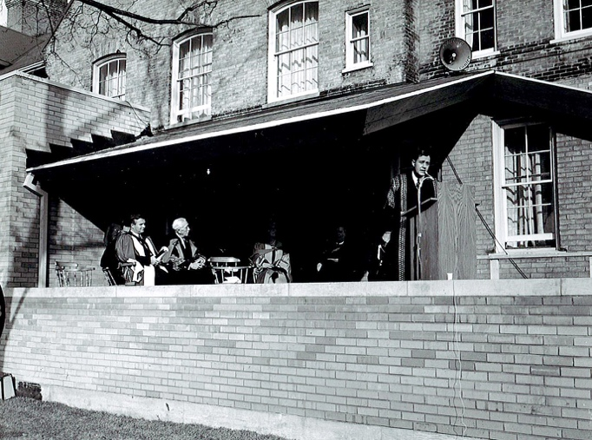
Tom Symons speaks at the official opening of Trent University in 1964. (Photo courtesy of Trent University Library and Archives, Parks’ Photography.)
Trent University is in a special sense related to the community in which it is located — to Peterborough, to the Valley of the Trent, and to Eastern Ontario. No new university has received a greater measure of support from its home community — as well as from many friends across the land. And it was this support and the dedicated service given by men and women here in the Trent Valley — many of whom are present today — which made Trent University possible and brought it into being.
...
It is very much the hope and wish of everyone associated with Trent University that it may become in the fullness of time a useful and significant centre for Canadian studies. By this is meant the study of our Canadian civilization — in its totality: its history, literature, art and institutions, its people, and its sciences. In relation to this program, Trent University is planning in the near future to give sponsorship and support to a new quarterly which will be known as the Journal of Canadian Studies.
...
But the character of this University is related to even deeper considerations than these striking physical factors of site and location — important though these are. It is the product primarily of the men and women who serve it and who are a part of it — of the founders and the donors, the governors and the staff, the students and — one day — the alumni.
…
In consequence, it may be fairly said that Trent has benefited from a programme of careful study and intensive planning extending over a number of years. In the age of instant coffee and even instant tea, we hold to the view that there is no such thing as instant university, or, indeed, as instant education.
...
The philosophy which inspires Trent is based upon the conviction that education is, inescapably, an individual experience — individual to each student, to each teacher, and to every scholar who may come to it. And this philosophy is reflected in the teaching methods of Trent University which seek to encourage each student to find a close and direct contact with his teachers through the tutorial and seminar method of instruction. The founders of Trent have kept in mind the dictum of Henry Adams that “A teacher is for eternity. He can never tell where his influence stops,” and they have thought therefore to place the first emphasis upon creating a university in which the standards of teaching and scholarship are the prime concern.
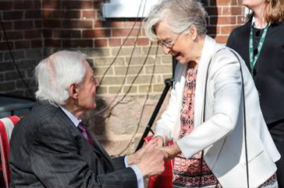
Tom Symons and Marion Fry, the founding principal of Traill College. (Photo courtesy of the Traill Tales newsletter.)
...
Every student and every faculty member will belong to one or another of these colleges. In this way, through the colleges, members of Trent University may be helped to preserve a sense of individual identity as the University grows larger, and to find richer personal associations and a greater measure of academic assistance than would otherwise be the case.
…
I am moved to hope — and to believe — that we are establishing here a great University, one of excellent standards and of fine character. May it give service to this community, to this Province, to Canada and to many scholars from lands overseas through generations yet to come.
Delivered by Tom Symons in Peterborough, Ontario on Saturday October 17, 1964.

In his own words: A look back with Tom Symons
To mark Trent’s 50th anniversary in 2014, Trent alumna Sylvia Dick interviewed Tom Symons for the TUARP Newsletter. The following are excerpts from that interview.
How did you come to accept the invitation from the Peterborough community?
One day I had a phone call, out of the blue from Peterborough, requesting that a few people come in for a chat. I said of course, with no clue what the discussion would be about. I had many students from all over, and one or two from Peterborough, and I thought perhaps it was about a student.
They came a few days later and I was astonished. In attendance was a doctor, a rabbi, a priest, the president of the Chamber of Commerce, a lawyer, president of Quaker Oats, a manager from GE, a union leader, president of the University Women’s Club of Peterborough and so on. I thought there would be one or two people but the room was full!
In discussions with officials at various levels of government and administrators at different universities, this group had been told by several people that they should chat with this young fellow. They asked; Would I be open to receive an invitation to be the founder of a university, working along with them.
I felt universities were getting too big too quickly. Their component parts were losing touch with one another, and I felt the quality of teaching was suffering. A huge emphasis was being put on post-graduate work and research, which of course is desperately important, but you can’t have good higher rungs of the ladder if you don’t have the lower down rungs in first-rate condition. You need good teaching and good undergraduate work if you are going to have good research and graduate work.
I went on to say to this group, that if they were interested in a university that wouldn’t rush to be big, that might in fact, deliberately go slow, and would focus on giving its students the best possible cultural and educational experience, and on quality teaching, then perhaps we could work on this together.
I left for a lovely walk. I saw the cathedral spire, one of the loveliest small cathedrals I had ever seen, and other wonderful old heritage buildings. I picked up a copy of the Peterborough Examiner and was astounded at the quality of content and writing (it was Robertson Davies who owned and edited it at the time). I got sitting down somewhere looking through the paper, and I lost track of the hour. By time I got back, the group asked me where I had been. They had made their decision within 15 minutes and I had been gone an hour and a half! They said ‘Yes, we’d like to do it. We’ll do it with you.’ We shook hands, and they never let me down for the next 10 years. They were the most marvellous group of citizens, and I hope that I never let them down.
You are known for your understanding of the importance of fun throughout a person’s career. Can you elaborate on that a little?
In its deepest sense, fun is terribly important. The question is; Are you enjoying what you do, even when it’s difficult? Are you sharing with others in a experience in which no matter how challenging, gives some measure of satisfaction and happiness and good feeling of what can be done?
By fun I mean a rewarding experience. It is a worthwhile and satisfying application of effort and achievement. Of course there should be some fun in the sense of merriment, too. I’m always delighted when that happens.
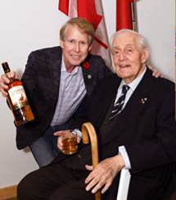
Tom Symons and current Chancellor of Trent University, Stephen Stohn. (Photo courtesy of the Traill Tales newsletter.)
Can you elaborate on the special nature of the opening ceremonies — with its inclusion of civic, Indigenous, religious, and labour leaders, and the Governor General?
Back during my first day at Rubidge Hall – at a time when the only employees were myself and the caretaker – representatives paid me a visit. At the time my office was furnished with a card table and a folding chair. I was just figuring out where to begin really, and the caretaker let me know that there were some people coming to see me. I was surprised and delighted to be greeted by the Band Council from Curve Lake, headed by the Chief. They had had a meeting the night before, and they voted to give $100 towards Trent and to make a presentation on behalf of the Band. It was the most wonderful gesture and was tremendously appreciated. I believe it laid the foundation for a special relationship with Trent and the Indigenous community, particularly Curve Lake but the wider community also.
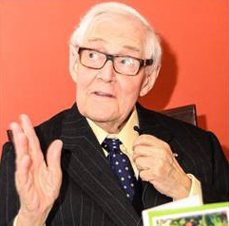
Tom Symons speaking at the Symons Seminar Series Gala in 2017. (Photo courtesy of the Traill Tales newsletter.)
Tell me about how you value the importance of conducting one’s affairs with courtesy and in a collegial manner, in every situation.
I think it’s extraordinarily important to take the time to understand and appreciate the various points of view that are involved. That’s the essence of collegiality. It leads to mutual understanding, accommodation and respect. I suppose that’s my way of life.
Where did this way of life come from?
I was rather lucky and I selected my parents with great care. They were astonishingly kind, patient and good humoured. My father was a businessman but was also a writer and he wrote in a very thoughtful and good-humoured way. A book of his won the first Stephen Leacock Award.
This way of life is what I believe in, and I was lucky enough to be taught it when I was young. I also happen to think it is the most useful way to proceed.
Interview by Sylvia Dick, a proud Trent alumna who now works as the Lady Eaton College Assistant.

Memories of Tom
These reminiscences were originally published on the Tom Symons Kudo Board.
Sadly, we have lost Tom but happily not our memories of him.
In 1969-70 I was one of many graduate students researching theses in the archives in Ottawa. Lunchtime conversations often turned to the academic job market and comparisons of universities. Trent attracted interest mostly because it was an outlier, a small, collegiate, undergraduate university amidst a field of academic factories. Tom Symons was just a name then: the focus was on the product of his vision. We heard they served sherry at Trent. I applied for a position. A requirement at the job interview was to have a personal meeting with the President: Tom conveyed a genuine interest in me. That fall, 1971, I got to attend the last of the legendary sherry parties that Tom put on for new faculty at Marchbanks.
Fast forward to November, 2018, and the opening of the newly renovated Bata Library. We know how Tom loved and understood the importance of books. We also know that beneath Tom’s masterful diplomacy resided some firm values and opinions. The plan to eliminate thousands of volumes in the transformation of the library understandably offended Tom, and many others. After chatting with Tom for a while at the re-opening ceremony I announced that I was going to tour the upper floors. Tom looked at me wryly and said, “tell me if you see any books.”
Dale Standen

A great Canadian
As I am sure you are aware, we lost our founding president on January 1, 2021. What a great Canadian Tom Symons was in addition to being such a wonderful, compassionate and kind person. He always found time to chat to people and was totally interested in their daily lives. I do find it somewhat overwhelming that we have lost two of our founding patrons, T.H.B. Symons and Dick Sadleir in such a short space of time.
Dick was very instrumental in establishing T.H.B.’s guiding principles for the founding of Trent. A third member of this founding triumvirate of Trinity College, the University of Toronto, graduates was John Leishman who passed some years ago but brought his financial acumen to the new university.
Tom was invited to become Trent’s founding president by a Peterborough citizens committee at the tender age of 31. His ideas were to build this new university on the banks of the Otonabee based on a liberal arts and science education with small group teaching and distinct colleges.
Tom had a hugely impressive list of awards, accolades and a long list of honorary degrees from both Canadian and Commonwealth universities. (However, there was only one ceremony, at the University of Columbo in Sri Lanka where he was escorted in the academic procession by a very large elephant.) In 1971, he was appointed chair of the Association of Commonwealth Universities and the fall meeting of the Association that year was held at Trent and became known as “The Council of Trent.”
Tom left an indelible mark on Canadian culture and was particularly keen on establishing and promoting Canadian Studies. If I may be so bold as to add my own personal thought, he would have been an outstanding proud and hugely impressive Governor General. Unfortunately, my idea did not come to fruition.
To learn more about this incredible individual and his achievements and honours, the book Tom Symons: A Canadian Life says it all. Edited by Ralph Heintzman, a former Trent colleague, it is made up of twenty chapters including a number written by the Trent colleagues and alumni, Denis Smith, Jamie Benedickson, Harvey McCue, David Cameron, Walter Pitman, Stu Robson and Sylvia Sutherland.
Tom always had terrific rapport with students and kept up that relationship when they graduated. He continued to get calls and visits from them over the last forty years. Perhaps one of his iconic and enjoyable gatherings was a cup of tea at Marchbanks, his home on Park Street for over 50 years.
One particularly poignant moment occurred one day when exiting his original office in Rubidge Hall, he encountered two students heavily embracing on a couch in the hall. T.H.B.’s immediate response to this affectionate scene was to invite them into his office for a cup of tea.
The seventies were a somewhat turbulent period for Canadian universities with numerous student protests taking place across the country but Trent was the only university to have a student protest to support the President and encourage him to continue in that role. He took their advice.
Tom was always incredibly supportive of the University’s faculty and staff and fully appreciated the role that they played in the student experience. He also was very supportive of the endeavours of TUARP and very much looked forward to the meetings and camaraderie of those gatherings.
I feel so fortunate to have known Tom Symons and been a part of his university of so many years. His extraordinary life has come to an end but his memory will always remain on the Symons Campus of Trent University.
Paul Wilson
Director of Athletics, 1966-2002
Honorary Alumni Ambassador

A long association
My long association with Tom began in 1956-1958, when I was a resident don at Devonshire House, (and lecturer in political science at the U of T), living downstairs in East House while Tom resided in his (larger) suite upstairs as Dean of Devonshire. After two memorable years there, I returned overseas to finish my graduate degree. I came back to Toronto in 1960, at the beginning of the decade of vast university expansion, and - at Murray Ross's invitation (he was vice-president of the U of T and president-designate of York) - I became the first paid employee of York University just a few months before it was to open (without any preliminary planning) in September. Murray, in his casual way, gave me a job and asked me what I wanted to do. I said (among other things) that the university needed a registrar to find and enroll students. Murray pronounced me registrar and lecturer in political science, and I began a hectic tour of Toronto high schools to find applicants. York opened with (I recall) sixty-five students. (Within the first year I persuaded Don Rickerd to cross Queen's Park and replace me as registrar while I carried on teaching politics.) Meanwhile Tom (still Dean of Devonshire) was invited to become president-designate of a new university in Peterborough. He created a planning committee and invited me to join; and with my experience of York's spare preparation, we agreed that Trent should begin with a planning year without students. Premier Frost accepted Tom's genial insistence. In summer 1963 seven of us (plus families) arrived in Peterborough. Trent was given the old South Central School as its starting place, adding a couple of houses to the north of it as the university came to birth. The university's permanent site, a gift of one hundred acres, grew at our recommendation to more than a thousand, purchased and expropriated, on both sides of the Otonabee River three miles north of the city. (The city expanded its boundaries to take it in.)
Meanwhile, Massey College was rising miraculously in the inspired architecture of Ron Thom. From across the street at Devonshire (and from elsewhere) it was noticed and admired. Trent's planners and board of governors prepared a selected list of planning architects, Thom among them, and when the time came for a final selection, Ron Thom was an easy choice. For the first three years after Trent's opening the university remained in its temporary quarters in town, with improvements added by the new university architect. In 1967, Trent arrived on the new campus, with the opening of Champlain College, the bridge on the Otonabee, and the planning and beginning construction of Lady Eaton College.
All of this planning and achievement occurred under the calm and inspired leadership of Tom Symons, whom I had joined along with others in creation of the new university. Unusually for Canadian universities, the detailed planning was led, under Tom's brilliant diplomatic guidance, by his academic staff, with the approval and encouragement of the board of governors. That, I believe, was something new in Canadian university history.
Denis Smith
An opportunity to meet a special person
This piece was submitted to the Editor in 2019. It was distributed at the TUARP Tea for Professor Symons.
My opportunity to meet that special person came back to me in 1974. When I applied for a job at Trent University I was interviewed by Mr. Bob Johnston. I got the job and I was told to go downtown and meet with a Mrs. Eileen Allemang. I said no as I wanted to work at Trent University. Bob’s reply to me was “Hell man, that is part of the university, that is Peter Robinson College!” So downtown I went, to Sadleir House at 751 George Street and met with Mrs. Allemang. Little did I know that I was to cross paths with a very unique man, the president of Trent University, Mr. Tom Symons.
Tom’s office occupied the whole of the little building known as “the Cottage” at 733 George Street. The Cottage stood between Reade House and the student residence. When I walked into his office it nearly took my breath away. There was a huge desk and what I thought were thousands of books completely lining the walls of his office and that of his secretary, Mrs. Fitzgerald, which took up all of the main floor of the little white cottage. I remember having to move most of his books down into the basement while we reinforced the posts under his floor because we were afraid the weight of his books might be too much for the little cottage. We then put all the books back in exactly the same order as they came out.
I remember many times when the big, black Capitol taxi would pull up in front of the Cottage on George Street. The driver would get out with his cloth and wipe off any little spots that might be on the car, and then sit on the fender patiently waiting for Professor Symons to emerge. In the meantime Professor Symons might be on the phone talking to someone from God knows where, or sitting at the desk talking to a student, or talking to Mrs. Fitzgerald about things he needed done while he was away. Eventually he would emerge from his office and have a little chat with the driver before getting in the back of the taxi (he never sat in the front) and then they were off, probably to the airport. I never saw Professor Symons drive a vehicle. I don’t think he would have time to be bothered with that.
One of the things I remember most about that man was how observant he was about everything that was going on at Peter Robinson, and no doubt the whole university. You could not plant a rose without him remarking it when you would meet up with him a couple of days later. He would say “Ferg, that rose looks so nice in that spot.” His comments were always positive. I remember him coming up the stairs into the dining room at Sadleir House. It didn’t seem to matter how many people were in the line up. He always took a moment to chat with the student taking the tickets or the servers, or whoever was around. Everyone mattered to him and he never got in a hurry.
I remember one Christmas day as I was making my rounds; I spotted Professor Symons walking around knocking on each resident’s door. If no one answered he moved onto the next door. I remember asking someone later what they thought he was doing and their reply was that if he found someone alone on Christmas day, the big man would invite them to his house. Ask him about this for verification and be ready for an enlightening answer.
Fergus P. O’Brien
Vision and leadership
This note was originally published on the Tom Symons Kudo Board.
It is with a great sadness to learn of the passing away of Professor Tom Symons. His vision of Trent and the leadership shown by him has left special memories for Trent University.
Professor Symons was always interested in meeting students at every chance he got. He then remembered them by their names; an amazing memory. I first met Professor Tom Symons on Thanksgiving Weekend in October 1968 for the Thanksgiving lunch/dinner for the foreign students attending Trent. This event was hosted by late Bob Johnston of Physical Resources Department of Trent at his farm. After meeting Professor Symons at this event he always remembered me for all these years. Trent community always meant so much for him.
Manindra Shah, Class of ‘68

Tom Symons: A Peterborough life
The following is Trent Valley archivist Elwood Jones’s review of Tom Symons: A Canadian Life, originally published in 2011.
Tom Symons is the subject of a current book, Tom Symons: A Canadian Life. The book has been edited by Ralph Heintzman, whom I remember as the founding editor of the Journal of Canadian Studies, Trent University’s first academic publication. My first academic article was published in that Journal in 1968, and it was my second pay check as a writer.
The book has 20 chapters written by 19 authors. Each of the authors was a partner with Tom Symons at some significant or characteristic aspect of his life. Parts of the book have a biographical flavour, while others are reflections of the moment. The book inspired a series of events held at Massey College at the University of Toronto, but jointly sponsored by Trent University. The events were free to participants as there were several generous donors. I attended the day-long conference in which most of the authors of the book spoke about their experiences in writing for the book, or of their memories of Tom Symons. As well, I was at the celebratory banquet, which also featured some fascinating insights. The combination was remarkable. Tom Symons emerges as somehow symbolic of the Canadian spirit for the last fifty years, even though he was unlike any Canadian we know. Many aspects of his life were familiar to me, as I have shared in some of Tom’s enthusiasms, and many of the writers were familiar to me personally or by reputation. Of 16 speakers, for example, eight had Trent connections, and I personally knew seven of them. A ninth had Peterborough connections because of riding in Capitol Taxis between Peterborough and Sturgeon Falls and Cornwall. Of the others, there was the Hon. Tom McMillan, a former federal cabinet minister, and John Fraser, the Master of Massey College, who is a leading Canadian journalist whose reporting has led to seminal books on public affairs, most notably the best-selling The Chinese. One of the speakers had known Tom Symons since undergraduate years at Trinity College. The three remaining authors captured quite distinct aspects of Tom Symons’ career. Alastair Niven spoke with authority about Tom’s remarkable career in serving and promoting the Commonwealth, and its various well-rooted educational partnerships. Christina Cameron, an insider with the Historic Sites and Monuments Board, captured Tom’s influence in making federal cultural heritage policy, and in determining sites worthy of historic commemoration. Edward MacDonald, a professor at the University of Prince Edward Island, captured the influence of Tom Symons as the most loyal “Summer Islander”; he has gone to the Island every summer since 1952, and over the past 25 years has been the most effective advocate of the idea of Prince Edward Island as the “cradle of Confederation.” One can easily summarize the contributions of Tom Symons to Canadian public life. He was the founder of Trent University, and a driving force behind the defining characteristics of its architecture, of residential colleges, of small group teaching, and a collegial community in which professors, students and administrators had shared visions. Denis Smith, a member of the inner group at the founding, spoke cleverly of the way these ideas worked in the early 1960s. Without Symons, the university would not have had the same sense of civility and concern for others. As well, the university might not have had the leavening of a university based on small residential colleges. Symons was effective at making his views known in Toronto, by politicians and public servants.
Jamie Benidickson, now a law professor in Ottawa, spoke from a student perspective. Tom Symons described himself as a “rambunctious undergraduate” but that seemed unlikely. He was, however, able to make significant changes in collegial residential life, notably at Devonshire House. Benidickson was more concerned about student life at Trent. Trent, he said, studied interdisciplinarity and public policy, and Symons invented the concept of “Canadianity” in reference to the totality of subject matter related to Canada. With respect to how we learn, he noted the importance of conversation, the concept of community, and contemplation (rather than conflict). He saw the bus running between Rubidge, Traill, Robinson and Champlain as a unique element in community formation, almost as important as Ron Thom’s architectural environment. The third aspect that seemed important to both Benidickson and Symons was the importance of teachers with scholarly values but “exemplary concern for students.” The Symons Teaching Award has honoured teachers who best represented these values. Harvey McCue, a Mohawk who came to university when it was still rare for Natives, and became one of the founders, at Tom Symons’ urging, of the Native Studies Program at Trent, the first in Canada and tied for first in North America. As with other students at Trent in the years before 1972, he was amazed at how much independence was given to students to perform above expectations. Symons’ faith in students was remarkably astute. Sylvia Sutherland, Peterborough’s mayor for 15 years, drew the honour of relating Tom and Christine Symons to the wider Peterborough community. Later, at the banquet, Mayor Daryl Bennett shared his unique perspective on Tom and Christine Symons. While driving Tom around the province, he experienced the world in his taxi-cab. Symons applied what he learned in Peterborough to the wider world. This was best reflected in Tom McMillan’s discussion of Tom Symons’ work with Robert Stanfield from 1968 to the mid-1970s. It was unusual for a political party to look outside politics to get someone to be in charge of policy initiatives. Stanfield was seeking ways to make the Progressive Conservative party appealing to academics and thinking people. Trent University was accepted as Canada’s outstanding small university. Symons, for his part, was committed to public service, and had shown an ability to develop university policies in the context of public policies which Symons had helped amend. His partnership with Stanfield was amazingly effective. Symons was the patient grey eminence for the Priorities for Canada Conference in 1969, and then headed the Policy Coordinating Committee. Symons found various ways for members of the political party to discuss policy issues. The party emerged from its populist phase under Diefenbaker with fresh credibility, nearly winning a minority government in 1972 and only losing in 1974 because of Liberal duplicity on wage controls. McMillan felt that the Symons and Stanfield partnership “elevated the political culture of the land as few other Canadians have ever done.” The key was not so much the policies as the process. Following the 1969 Niagara Conference, Symons’ committee held dozens of meetings, generated countless position papers, recruited over 500 experts, and developed 260 resolutions for the 1971 annual meeting. All delegates had packages loaded with information long before the discussions occurred. It was a tour de force, which the convention recognized. The process may be the key to understanding Symons. His legendary Canadian Studies Commission and the recent commission studying the future of the Trent Severn Waterway gathered briefs, produced reports, revised reports, made recommendations and found ways all along to be open and accessible. This echoed aspects of how Trent University came to Peterborough. Reg Faryon wrote his famous letter in 1957 suggesting Peterborough should have a college. Robertson Davies hoped for a real university. The local committee met discouragement in Queen’s Park until they found three advisors from Queen’s, Toronto and Western. As Denis Smith observed, Symons orchestrated planning. He developed policies for a university meeting his vision, but he also curried support at the provincial level, among leaders and labour unions in Peterborough, and created wider sympathy for the new Trent University.
Many people at the conference could not imagine Canada without Tom Symons. He seemed to be everywhere that mattered as Canadians for half a century hammered out policies related to universities, education, heritage, Canadian Studies, Indigenous Studies, and to culture. Trent was an exciting place where lots was happening. I thrived in its classes, colleges and architecture; I loved its committees and its discussions. I loved its peerless setting across a beautiful river, at the base of a drumlin on one side and a prehistoric river valley on the other. Thomas Jefferson’s greatest achievement, in his own view, was the establishing of the University of Virginia. Tom Symons; greatest achievement was founding Trent University. For Symons, it was the key to all that followed. His was a remarkable life that impacted on some of us more than others.
Elwood Jones and Trent Valley Archives express sincere condolences to Christine and the family. Tom Symons had a remarkable life and embodied the qualities that were synonymous with Trent University.

A student’s perspective
As a graduate student, I spent one unforgettable year meeting fireside with Thomas H.B. Symons, C.C., who kindly offered to supervise my M.A. thesis in his retirement. Former chair of the Ontario Human Rights Commission and several national commissions, as well as president of the Association of Commonwealth Universities, Professor Symons exhibited a public ethic that reflected the spirit of diverse groups of people achieving a goal together, whether in nation-building, the war effort, Commonwealth university education, the study of Canada, or the conviviality of his Methodist ancestors, to name his best-known affections. Though we were supposed to be talking about the importance of Canadian literature and education in our era of vast technological change, I realize that I was really getting a study in civic virtue.
Tom’s decency was most visibly practiced as collegiality, a value he literally designed into the architecture of Trent University when as its Founding President he adapted the Oxford college model to Canadian higher education. For most of Trent’s history, students, tutors, administrators, and support staff have treated each other as equals in a community. I came to see afterwards that during my personal tutorials at his home, Tom pushed me to understand magnanimity – often his own – the broadminded public virtue defined by Aristotle as “highness of soul” and by Cicero as honestum decorum, “the will to do a kind service, even though nothing happens to come of it.” Leaving a meeting at Tom’s house, you felt, for a time, that you could make anything happen, so long as you put your mind to it. When I moved to Toronto to carry on my graduate study, I met enough others who shared similar experiences of Tom to realize that such feelings were typical of the influence of Professor Symons’s great spirit. True to these attributes, he also became a dear friend.
Owen Kane
(Owen is a scholar of civic virtue, completing his Ph.D. at Queen’s on decorum in early modern literature and education. He is the son of Sean Kane, Professor Emeritus of Cultural Studies and English Literature. Kane can honestly say that during his B.A. and M.A., the majority of his instruction, both personal and academic, came from Trent retirees.)

One fond memory
One fond memory I have of Tom Symons is as follows:
After working at Sadleir House, Peter Robinson College for about a year, I knew I had “arrived” when I was invited by Professor Tom Symons to tea at “the cottage” on George Street. It was a momentous occasion for me!
Winnie Janzen

Exploring further
Peter Northrop alerted the Editor to an interview with Tom Symons recorded in 1969 for the CBC program Matinee that is available online. To listen, click here. Or, type this URL into your browser: http://tklccloud.ca/MP3/Matinee.mp3

To listen to a podcast produced by Arthur Newspaper to mark Tom Symons’ passing, click here. Or, type this URL into your browser: https://www.trentarthur.ca/podcast/episode-9-the-symons-legacy
Co-Chair’s Remarks
Dear Mrs. Symons and family,
On behalf of the members of the Trent University Association for Retired Persons (TUARP), we would like to express our condolences on the loss of Tom.
We appreciate all he has done for Trent and post secondary education world wide.
He was very supportive of TUARP and attended many events over the years. He is held in high esteem by all our members and will be missed.
May your many cherished memories help bring you peace and comfort.
Gina Collins, TUARP Staff Co-Chair

TUARP DUES
Voluntary annual dues of $10 are now being accepted. Thanks to the hard work of our Treasurer John Casserly, you can now pay dues through online banking e-transfer. Add tuarp@trentu.ca to your account and complete the transfer. You may also pay by cheque. Please make payable to TUARP and mail to:
TUARP, Trent University, 1600 Westbank Drive, Peterborough, ON K9L 0G2
TUARP does not track dues in arrears. We are grateful for your support as convenient.

TUARP PURPOSES
[From the Constitution of the Association of Faculty and Staff Retirees of Trent University-Approved October 24, 2001]
- To facilitate the continuing association of its members with Trent University and each other.
- To safeguard and represent the interests of its members with Trent University and with faculty and staff unions.
- To monitor the pension and benefits entitlements of its members.
- To serve as a potential resource pool of expertise and knowledge for the benefit of Trent University
Reminder to update contact information
Don’t miss TUARP newsletters or meeting notices - remember to keep your contact information up to date!
If you have moved, changed phone numbers or email addresses, be sure to update your profile by visiting https://mycommunity.trentu.ca/myprofile or email advancementservices@trentu.ca

TUARP EXECUTIVE
Staff Co-Chair: Gina Collins
gcollins@trentu.ca
Faculty Co-Chair: to be determined
Secretary: Janice Millard
jmillard@trentu.ca
Treasurer: John Casserly
jcasserly@trentu.ca
Social Convener: Julie Crook
jcrook@trentu.ca
Newsletter: Tony Storey
tonystorey71@gmail.com
TUARP acknowledges with thanks the financial assistance of Trent University. Submissions for TUARP “Times” are strongly encouraged. Deadline for submissions for the next edition is September 1, 2021 and may be sent to tonystorey71@gmail.com. Past issues of TUARP “Times” are posted on the TUARP website:
https://mycommunity.trentu.ca/tuarp

