
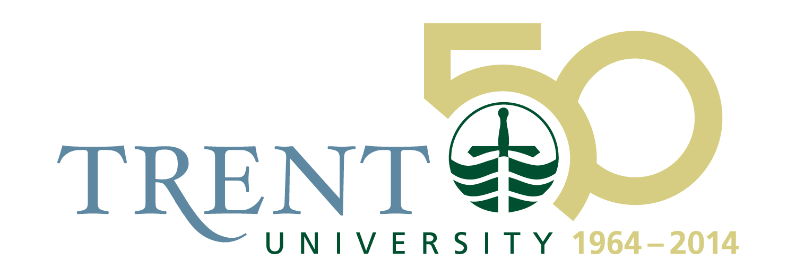

FOR IMMEDIATE RELEASE

CBC Radio Host Shelagh Rogers to Visit Peterborough as Jack Matthews Fellow January 27 – February 2

Series of events planned throughout the community

Friday, January 10, 2014, Peterborough

Renowned CBC Radio host Shelagh Rogers will be visiting Peterborough to deliver a number of public talks and presentations at Trent University, Lakefield College School and The Canadian Canoe Museum as the Jack Matthews Fellow during the week of February 27 – February 2, 2014.

Created in 2008, the Fellowship honours the founding leadership contributions of the legendary educational leader Jack Matthews to Trent University, Lakefield College School, and The Canadian Canoe Museum.

As the 2013-14 Jack Matthews Fellow, Shelagh Rogers will engage people throughout the Trent community in a variety of events. In addition to interacting with students in formal and informal environments in the colleges of the University, Ms. Rogers will be a part of events on the Curve Lake First Nation, Lakefield College School, the Canoe Museum, and at the Market Hall.

"The Jack Matthews Fellowship is a great way to honour the founding director of the Trent International Program, and to reflect on the deeply Canadian kind of global citizenship upon which TIP is established,” said Dr. Michael Allcott, head of Champlain College and director of TIP. “As the one who many of us recognize as the voice of contemporary Canadian culture and literature, Shelagh Rogers is perfect in this role. Not only does she live and breathe the diversity of writing and culture in Canada, but her work with the Truth and Reconciliation Commission makes her a champion of social justice and an extraordinary embodiment of engaged citizenship."

Highlights of Ms. Rogers’ visit to Peterborough as the Jack Matthews Fellow include:

Lakefield College School Visit
Tuesday, January 28
Ms. Rogers will visit Lakefield College School, sharing her experience with and knowledge of a broad spectrum of Canadian poets and writers. Having interviewed nearly every Canadian poet and writer from Leonard Cohen to Joseph Boyden, Ms. Rogers is known as the voice of Canadian literature and culture.

Speaking My Truth – Panel Discussion
Wednesday, January 29; 4 p.m.
Champlain College Great Hall, Trent University
Ms. Rogers serves as an honorary justice of the Truth and Reconciliation Committee, and has co-edited the book Speaking My Truth: Reflections on Reconciliation and Residential Schools. At this event, Ms. Rogers will be joined by co-editors Mike Degagne and Glen Lowry, as well as Drew Hayden-Taylor and Alice Williams. The panel will share their stories and experiences regarding surviving residential schools and Canada’s process toward healing. Copies of the book will be available.

An Evening with Shelagh Rogers at the Canadian Canoe Museum
Thursday, January 30; 7 p.m. to 9 p.m.
An evening with Shelagh Rogers in conversation with Canadian Canoe Museum executive director, James Raffan, talking about three of her favourite things: writers, writing and the North. Live conversation will lead into a screening of Ms. Rogers’ recent documentary Northwords, which documents Rogers’ experience camping and reflecting on inspiration in the Torngat Mountain National Park in northern Labrador with five Canadian writers. The screening will be followed by a Q&A period and refreshments. Admission to this event is by donation.

Women and Mental Health: A Conversation with Shelagh Rogers
Friday, January 31; 1 p.m. to 3 p.m.
Widely recognized for her advocacy for people with mental health challenges, Ms. Rogers will share her personal perspectives on depression in order to shed light on and challenge preconceived ideas about women’s health. The event is hosted by PARN: Your Community AIDS Resource Network and numerous community partners.

Elders Gathering at Trent University
Saturday, February 1
Ms. Rogers will be the keynote speaker at the annual Elders Gathering at the First Peoples House of Learning at Trent University. She will also be the guest of honour at an Order of the Bon Temps dinner for Trent University’s Champlain College alumni.

About the Jack Matthews Fellowship
The Jack Matthews Fellowship was created in honour of the founder of the Trent International Program (TIP) at Trent University, former headmaster of Lakefield College School, establishing director of the Canadian Canoe Museum, and founding director of Pearson United World College of the Pacific in Victoria, BC. Previous recipients of the Jack Matthews Fellowship have included Joseph Boyden, Nicolas Dickner and Mike Robinson.

- 30 -

For more information, please contact:
Dr. Mike Allcott, head of Champlain College and director of the Trent International Program, Trent University, (705) 748-1011 x1280 or michaelallcott@trentu.ca

