
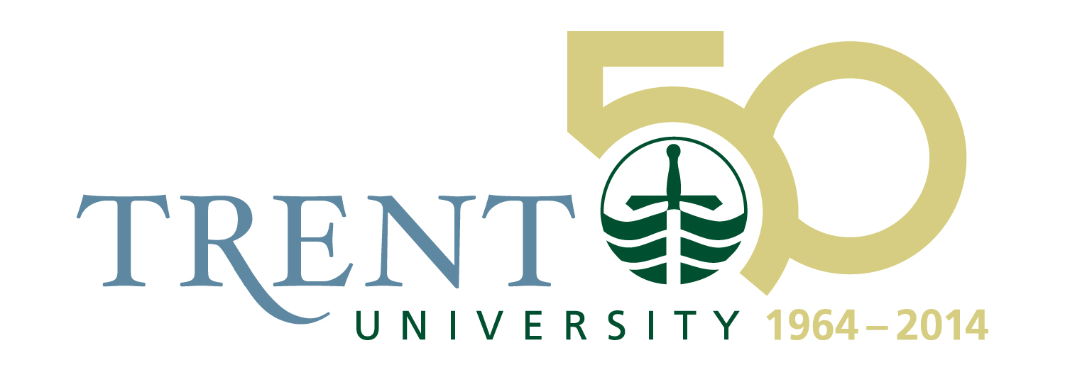

FOR IMMEDIATE RELEASE

Giller Prize-winner Joseph Boyden to Visit Students at Trent University

Canada Reads Author named the 2012 Jack Matthews Fellow, to be in residence at Trent, Canadian Canoe Museum, and Lakefield College School

Friday, September 21, 2012, Peterborough

Canadian author Joseph Boyden, a long-time friend and admirer of Trent University and its distinctive commitment to the individual student, returns to Peterborough on Tuesday, September 25, for a week-in-residence as the 2012 Jack Matthews Fellow.

Joseph Boyden rose to international literary prominence on the publication of his first novel, Three Day Road. His subsequent novel Through Black Spruce won the Giller Prize in 2008.

During his residency as the Jack Matthews fellow, Mr. Boyden will engage with student groups at Trent University, visit classes in creative writing and Canadian Studies, and participate in a Traditional Teaching Circle at the First Peoples House of Learning, among other activities. He will also spend a morning with students at Lakefield College School.

The fellowship week will focus on Mr. Boyden’s thoughts in a talk he’ll present entitled, “A Walk to Morning”. In this deeply personal talk on an at times difficult subject, Boyden will address the issues faced by aboriginal youth in rural and urban environments, and our societal implications in those challenges. While best known for his fictional writings, his essays have also won acclaim. His 2007 published lecture From Mushkegowuk To New Orleans: A Mixed Blood Highway is considered a manifesto on independence from oppressive governmental cultures.

Mr. Boyden will speak at the Canadian Canoe Museum on Tuesday September 25, 2012. Doors will open at 6 p.m. for the talk beginning at 7 p.m. followed by a book signing. The Museum and Museum Store will be open, with wine and cheese being served. Tickets are $25.00/person, available in advance at the Museum. www.canoemuseum.ca

The Jack Matthews Fellowship annually honours the memory of the founding director of the Trent International Program, who established the ideals of Canadian global citizenship at the core of undergraduate life at Trent. The Fellowship is a collaboration amongst the Canadian Canoe Museum, the Lakefield College School, and Trent University—all organizations in our community that owe a great deal to Mr. Matthews’ leadership

-30-
For more information, please contact: Michael Allcott, 705-748-1011 ext. 1280, michaelallcott@trentu.ca

